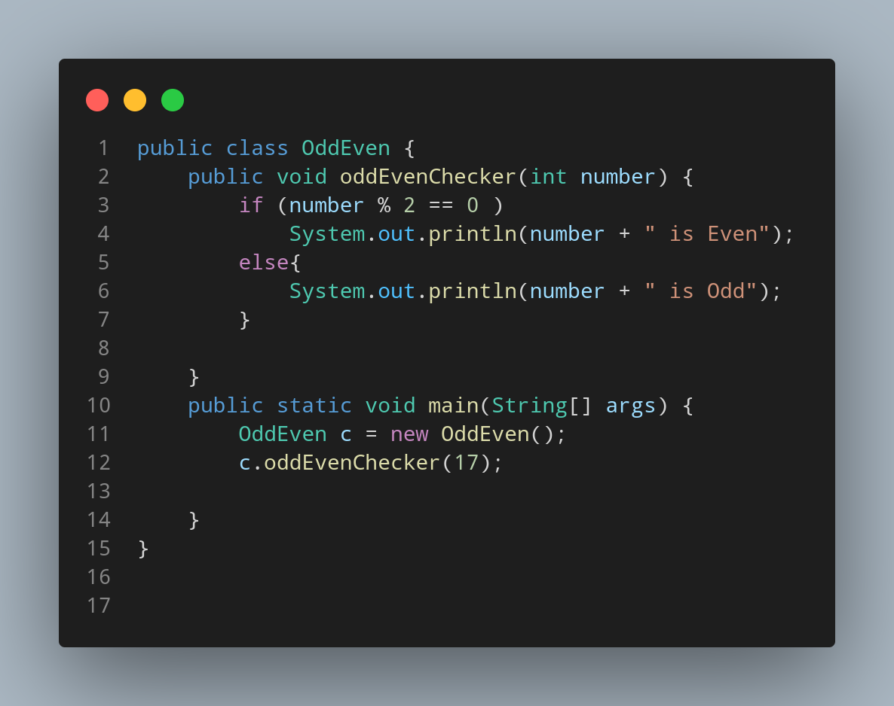

#Doc

We created our java file naming OddEven so , we create a class having same name. Inside our class we created a method named oddEvenChecker having int number as parameter.

Let’s start a if statement and compare if our given number % 2 is equal to 0 or not.If the statement is correct then run System.out.println(number + " is Even");. Else print System.out.println(number + " is Odd")

Now its time to create our main function.
Within main function first we instantiate our OddEven class data type as variable c. Then we call our method giving the value of function parameter during calling method.

